Soldron Wärmetechnik  Vertriebs GmbH  Ringstraße 17, 97950 Großrinderfeld  Germany  Tel/Fax: 0049 (0) 9349/ 768  www.waermeboden.de  info@Waermeboden.de | Visit these pages:  http://www.waermeboden.de/info/infoeng.htm  http://www.waermeboden.de/titeleng.htm  http://www.soldron.de/easyeng.htm  www.waermeboden.de/eng/montageeng.doc  http://www.soldron.de/eng/montageeng.htm
Overview of FH, FH-TWIN THERMOFLOOR and WARMTOUCH
The high quality heating mats:

Warmtouch WT PV-S-10N  Woven fabric, height 3mm  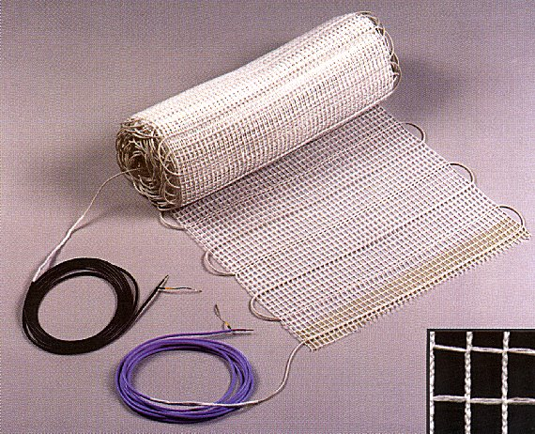 | ThermofloorS  Woven fabric, height 3.5mm  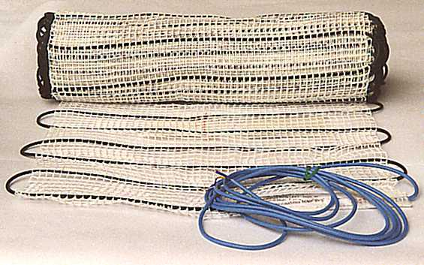
FH-TWIN  Reinforced fabric, height 2mm FH-TWIN 2.5mm  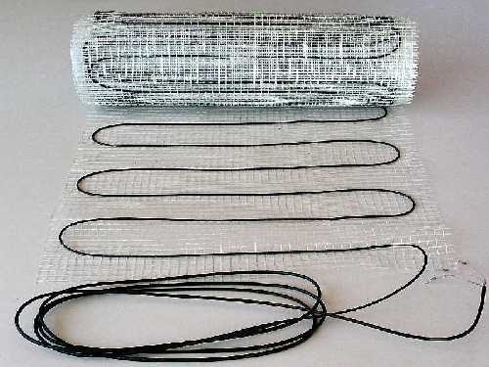 | Warmtouch WT PV-3L-5N  Woven fabric, height 3mm  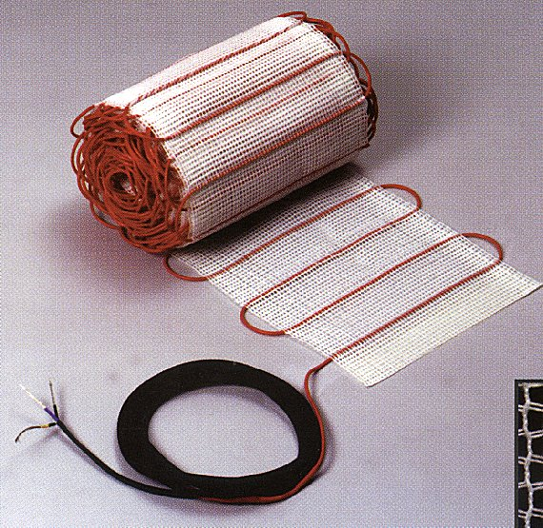

What are FH, FH-TWIN, Thermofloor and Warmtouch?

The heating wire is wound into a woven or a reinforced fabric.
The heating wire has a diameter of only 3 or 4 mm, is moisture-resistant, totally insulated and is sheathed in a protective wire mesh; it is made from a high quality resistance alloy.
4m long PTC resistor connection leads (neutral/PE, phase, PE) made from tin-plated copper are attached at the beginning and end of each heating mat.
The connecting sleeves are absolutely watertight, strain relieved and can also withstand high temperatures (80°C).
The heating mats can be laid flat on the floor base with no bulges as a result of the highly flexible fabric weave.
The heating mats are available in two different lengths, 0.3m and 0.5m, suitable for different floor sizes.

The 120 Watt/m² version is designed for heating carpeted, PVC or parquet floors, whereas the 160 Watt/m² or 120 Watt/m² version is suitable for tiles and stone floor coverings. 160 Watt/m² or 200 Watt/m² heating mats are designed for use in conservatories and in the bathroom.

120 Watt/m² heating mats are most appropriate for taking the chill evenly off larger living areas (or e.g. for Fermacell, Soporo, Majestic or Wedi boards).

Page 2

Laying examples:

The heating mats can be laid on any smooth underfloor surface such as concrete, moisture-resistant chipboard or dryfloor covering (as often used in the redevelopment of older buildings).

Follow the instructions for positioning and laying ceramic tiles and boards on chipboard issued by the German Tile Industry Guild (or equivalent).
It should be noted that even hot or poured asphalt can only withstand temperatures of 80°C.

The heating elements are very flexible when laying. The wound pattern of the heating wires means that there is a wide variety of laying possibilities. Maximum adaptation is possible for the most diverse range of floor layouts (with two laying widths: 0.3 and 0.5 m).

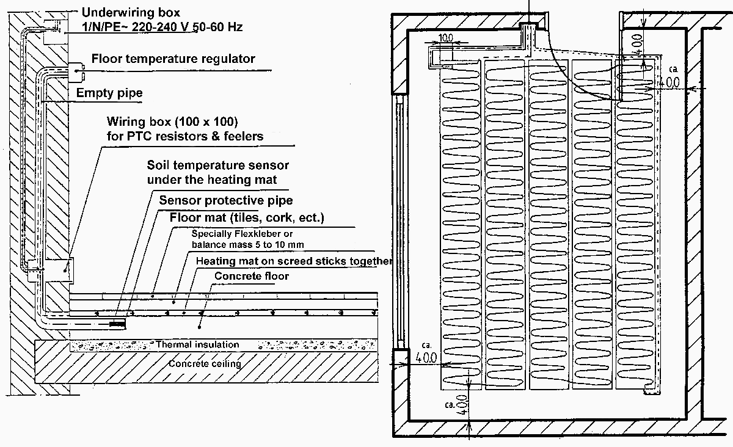 | 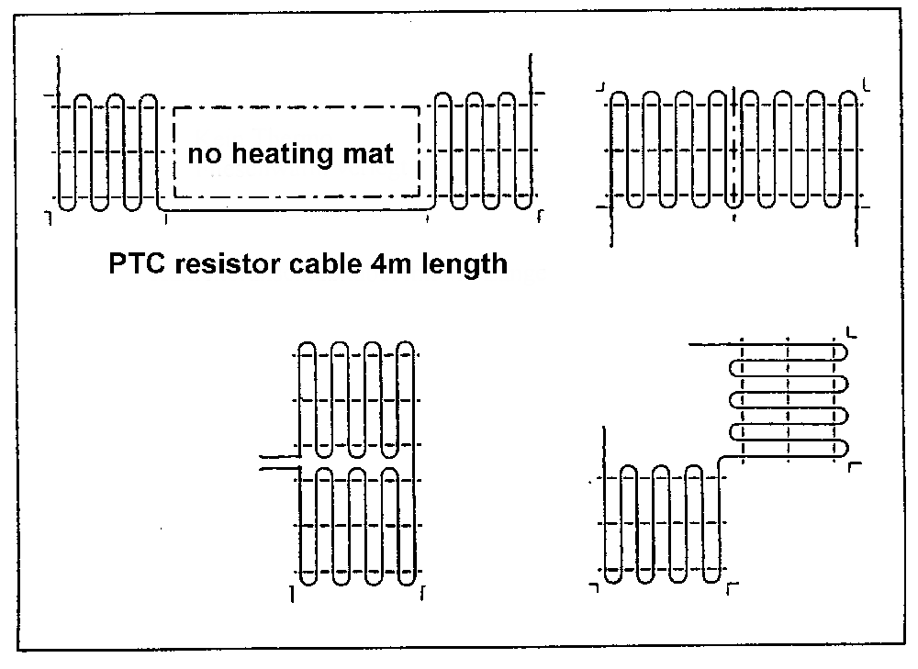
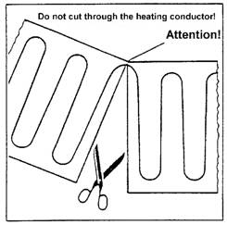
By cutting the fabric weave with a pair of household scissors, the heating elements can easily be adapted to the required outline as shown in the laying plan.
The sensor protection tube now needs to be laid so that the sensor can be fed from the heating connection box into the protection tube and laid beneath the heated area.
After this you can start to lay the cut-to-size heating mats on the dry, smooth and dust-free ground using a heat-resistant (80°C) tile adhesive from Knauf or PCI.

Press the heating mat with heating wire into the adhesive, ensuring that the heating wires do not touch or overlap.
It is extremely important that the heating mat is applied evenly without trapping any air beneath it. Lay the decking surface using tile adhesive, smoothing it down to provide mechanical protection when laying cork, PVC etc.

Page 3

Electrical connections in the UP heating connection box:

The electrical fitting of the underfloor heating should be undertaken by a certified electrician in accordance with the current VDE regulations and these fitting instructions.
The volume resistance (conductivity) of the heating mat should be measured continuously during the entire fitting procedure.
The continuous measurement of the volume resistance ensures that any damage to the heating mat is detected immediately and that the damaged item can then be exchanged for a fully functioning one.
The Ohm value of each mat should be entered in the room layout plan and on the rating plate (junction box).
The heating circuit should also feature a 30 mA circuit breaker, especially in showers and bathrooms, to ensure protection and safety against dangerous electrical shocks (unless the apartment as a whole, or at least the bathroom junction box from where the heating current originates, is fitted with a circuit breaker).
The connection leads of the heating mat and the temperature sensor routed into the embedded junction box should be connected as per the circuit diagram below. Make sure the PE wire (yellow/green) is properly connected.
Multiple heating mats should only be connected in parallel.

Temperature regulation:

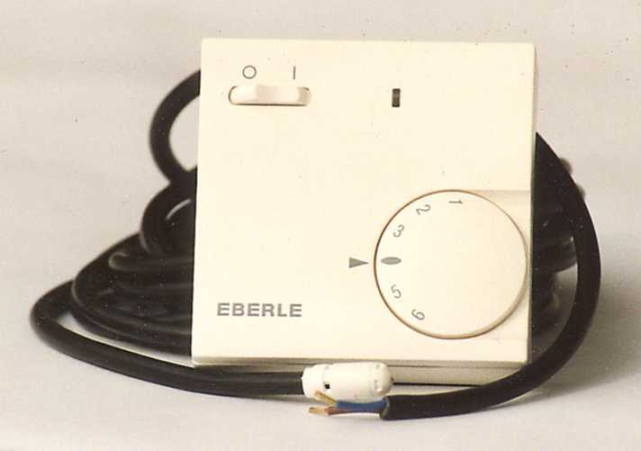
EB 52531
The floor temperature is measured by the NTC sensor and regulated by means of the EB 52531 electronic thermostat. The sensor of the thermostat is laid in the floor beneath the heating wires in the sensor protection tube, directly beneath the heating layer. The floor temperature can be set on the thermostat to meet your personal requirements and those of the particular room (living room or bathroom).

EB EASY 3 ft EB 52535 OJ OTN & OCC2/D2
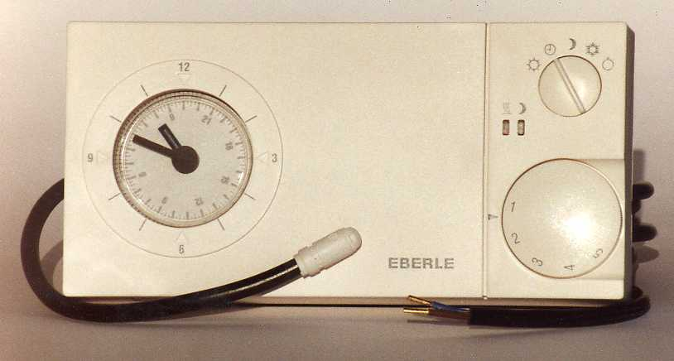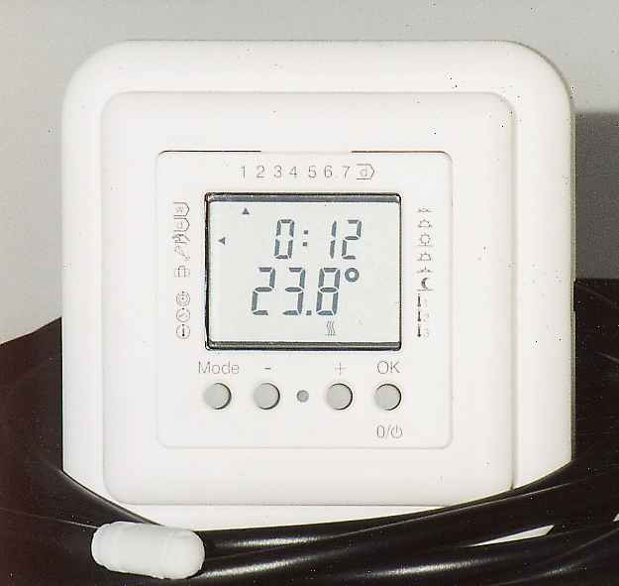 | 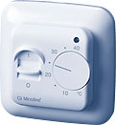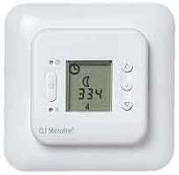
Timed operation by the EASY 3 ft (daily timer switching) or EB 52535, or OCC2/D2 (daily and weekly timer switching) timer thermostats is highly economical, yet there is no loss of comfort or convenience. The electronic thermostat should be set so that it automatically switches on the heating 30 minutes before the room is to be used. The unit switches off again automatically during or after use, preventing any unnecessary heating. You can also switch the heating on and off outside the times set on the timer, of course.

Page 4

Example of cable laying:  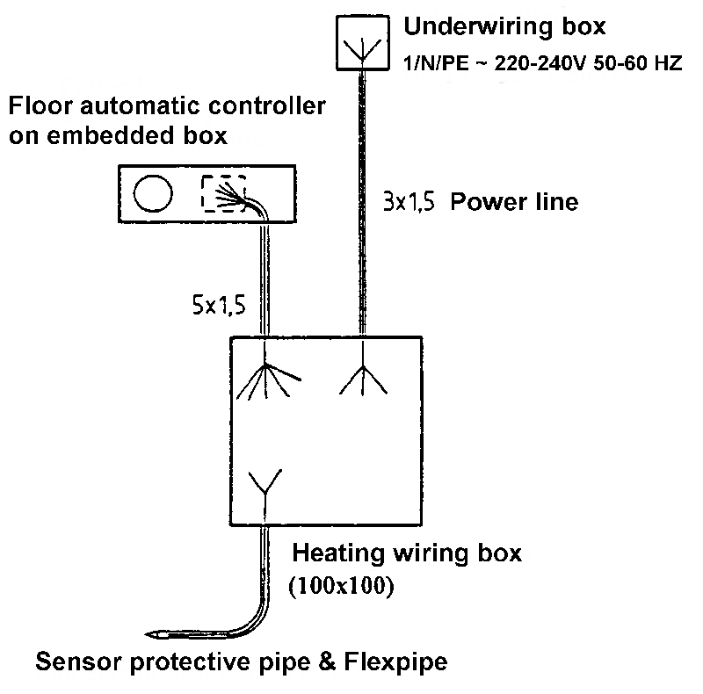 | Example of wiring:  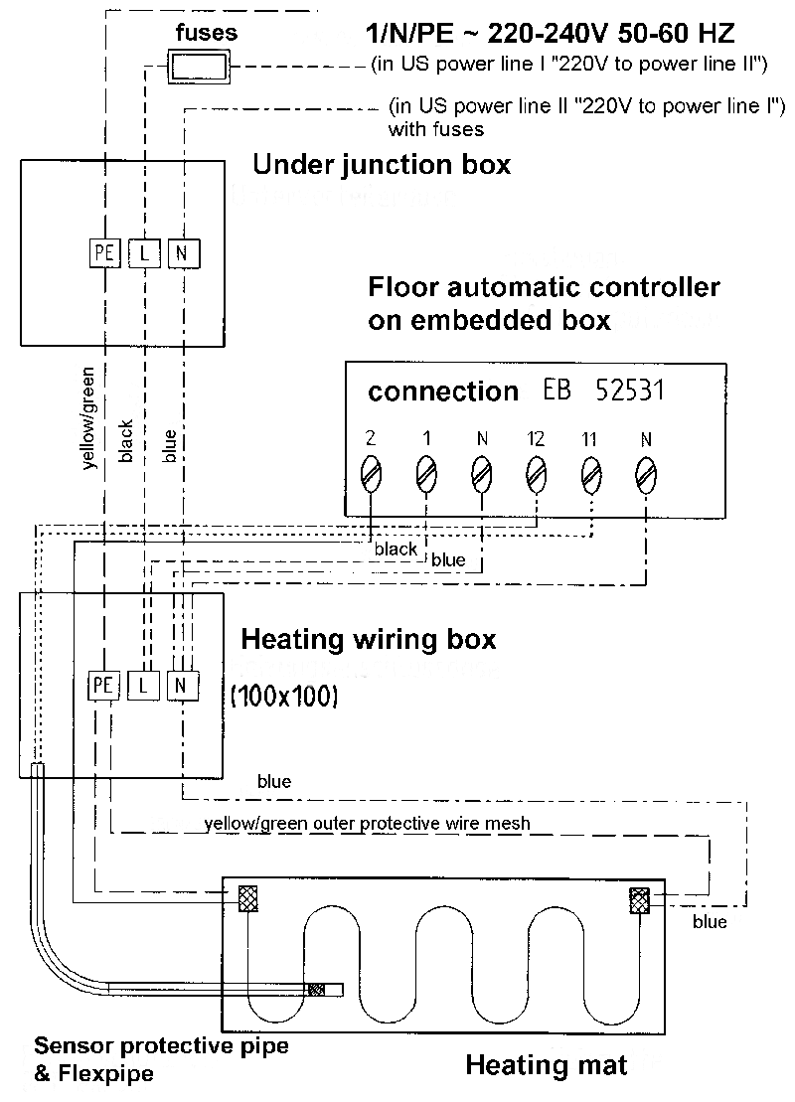

Full instructions for assembly and operating are enclosed with each delivery.

Applications:  * Tiled stove heating  * Bathroom, kitchen, nursery  * Selling areas, e.g. butchers  * Offices  * Low raised floor height  * Aesthetic reasons (no radiators)  * Renovation of old buildings (e.g. dry floors)  * Partial floor heating for seating area  * Conservatory frost protection | Advantages:  * Quick and easy to lay  * Rapid heating to desired temperature (bathroom in morning)  * Controlled by timer thermostat  * Extremely thin heating mats, 3 mm and 4 mm thick  * Safe, low-cost, maintenance-free  * Conforms to international standards  * Warm feet, cool head  * Pleasant house temperature  * Lower temperature possible through high heat radiation
Please read carefully - important for understanding floor heating:
Heating and electricity consumption

If 160 Watt/m² floor heating is fitted in a room with floor tiles, the heating only consumes 160 Watt/m² during the warm-up period, e.g. from 18°C to the target floor temperature of 24°C. At 160 Watt/m² rating this is of course correspondingly faster than 120 Watt/m² - and you save time in the warm-up phase. Subsequently the floor heating, i.e. from the surface of the floor tiles, only releases approx. 10 Watt/m² heating power into the room for each degree Celsius warmer than the room itself. Roughly half of the heat is released into the room in the form of infrared heat, i.e. radiant heat.
If the temperature in the room is 22°C and the floor is 24°C, the floor heating would then only release 20 Watt/m² into the room. If the room is warmed e.g. by the sun to 24°C, the floor heating will release no more heat at all into the room and therefore not consume any more electricity. This is the self-regulation effect of floor heating. The high percentage of radiant heat in floor heating means that the room temperature can easily be turned down by several degrees to e.g. 20°C, and it will still be perceived as pleasantly warm. A floor temperature of 21°C is felt as warm (the emphasis here is on the feeling of comfort created by floor heating - the prime source of heating is e.g. radiators). In this case the floor heating would only release 10 Watt/m² into the room.
With a heating area of e.g. 10 m² and a rating of 10 Watt/m² this would result in electricity costs of 15 cents for 10 hours at a price of 15 cents/kwh. This assumes adequate thermal insulation beneath the floor base.
In an extreme case, a 160 Watt/m² floor heating system would heat a room from 20°C to 36°C (i.e. one degree per 10 Watts) if it were not limited by the thermostat to approx. 28-29°C.
If the floor plate is thick enough, e.g. 8cm (e.g. heating base from Knauf) and if the customer has access to suitably low-cost storage heating electricity, it is also possible to heat an entire apartment or individual rooms with night storage underfloor heating. The investment costs are relatively low. If the intention is to use the underfloor system as the main source of heating, it is important to use night storage current or, better still, to change to a night-heating tariff.
The consumption costs are …, i.e. one litre of heating oil provides 10kW/h of chemical energy although only 80-90% is actually used as heat in the flat (boiler, radiation and chimney losses). In the case of electricity, however, 100% is given up to the floor surface. And there are no costs for chimney sweeps, boiler maintenance or fume emission measurement.

